**OSGI Configurations**

Configuration that our site can make use of.

Declarative services – It’s a framework which has been implemented in AEM. Which facilitates in writing the configurations, services and everything.

* [@Component](https://felix.apache.org/documentation/subprojects/apache-felix-maven-scr-plugin/scr-annotations.html#component)
* [@Activate, @Deactivate, and @Modified](https://felix.apache.org/documentation/subprojects/apache-felix-maven-scr-plugin/scr-annotations.html#activate-deactivate-and-modified)
* [@Service](https://felix.apache.org/documentation/subprojects/apache-felix-maven-scr-plugin/scr-annotations.html#service)
* [@Property](https://felix.apache.org/documentation/subprojects/apache-felix-maven-scr-plugin/scr-annotations.html#property)
* [@Reference](https://felix.apache.org/documentation/subprojects/apache-felix-maven-scr-plugin/scr-annotations.html#reference)

All these annotations are related to declarative services framework.

What does Declarative Service framework do?

When we define any OSGI configuration we mock that as an OSGI component with @Component annotation.

**Ex:**

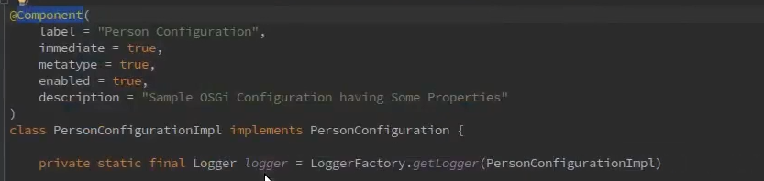

When this code is deployed on AEM, then Declarative services figure out that we have created a new configuration and it would create a new configuration in felix console.